**Y.NAVEEN KUMAR REDDY 192111405**

**8**

**.**

**Airport Management System**

**1**

**.Class Diagram**

**2**

**.Usecase Diagram**

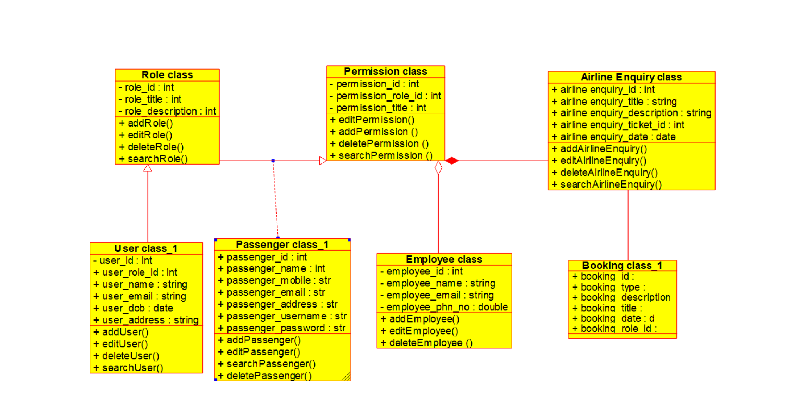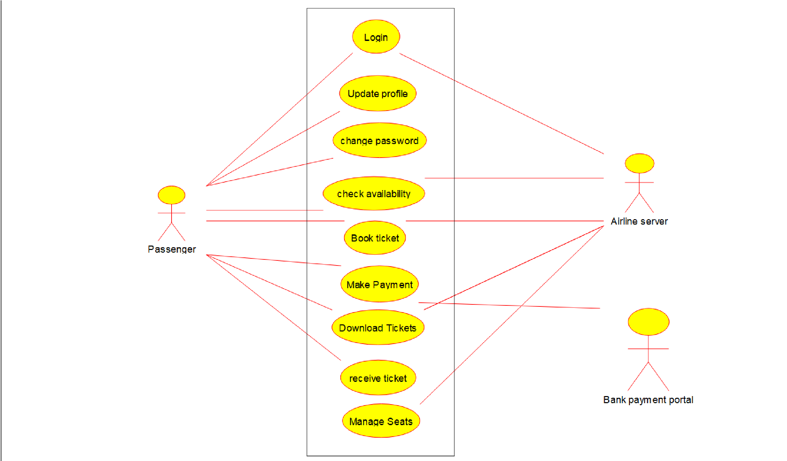

**3**

**.Sequence Diagram**

**4.**

**Activity Diagram**

